Low Level Design Document (LLD) v1.0

Project Management

Project Number #
Project Name
HLD (ID / Name)
Business Owner
Functional Area
Description

Change Management

IT Review
Role | Name | Revision # | Comments | Date | Initials
Technical Lead
Software Engineer
Testing Engineer

Revision History
Date | Revision # | Author | Comments

Table of Contents
1. Introduction 3
2. Requirements Traceability to Design Elements 4
3. Design Overview 4
3.1.1. Design Summary 4
3.1.2. Component Summary 4
4. Design Assumptions 5
5. Design Risks 5
6. Architecture Implications 5
7. Error Handling 5
8. Test Plans 5
8.1.1. System Test Cases 5
8.1.2. Integration Test Cases 5

Introduction

The low level design should provide the design to address how an individual component of the overall solution will address the subset of Non-Functional Features listed in the HLD. This is where the software engineer can identify opportunities for reuse of code, configuration elements and sub-components in the design. Business logic should be clearly articulated along with all key decision points with paths clearly labeled. Data elements should also be identified along with any transforms and storage needs. Key design-time versus run-time decisions should be highlighted along with any portions of code that represent high levels of complexity (as these could be areas of risk during testing and/or future maintenance). Design assumptions, limitations and dependencies should be highlighted as well. The LLD will have several versions to accommodate specific needs based on component TYPE (SAP – Process, SAP – Report, SAP –Screens, Integration – NetWeaver, Integration – Other, Non-SAP – Process, Non-SAP – Report, NON-SAP – Screen) The list of steps for the software engineer will vary based on the component type (LLD Version):

Step 1: Carve out the subset of Non-Functional Features specific to this component design
Step 2: Tie the design elements for this component back to the list of Features
Step 3: Document the detailed design for this component
Step 3: Capture the assumptions used to create the solution
Step 4: Capture the risks associated with the design
Step 5: Document the Architecture Implications from the proposed design (esp. where we deviate from stds)
Step 6: Identify the Error Handling Requirements to address resiliency & adaptability in the design
Step 7: Document the Test Plans covering System & Unit Test Cases

Development Methodology

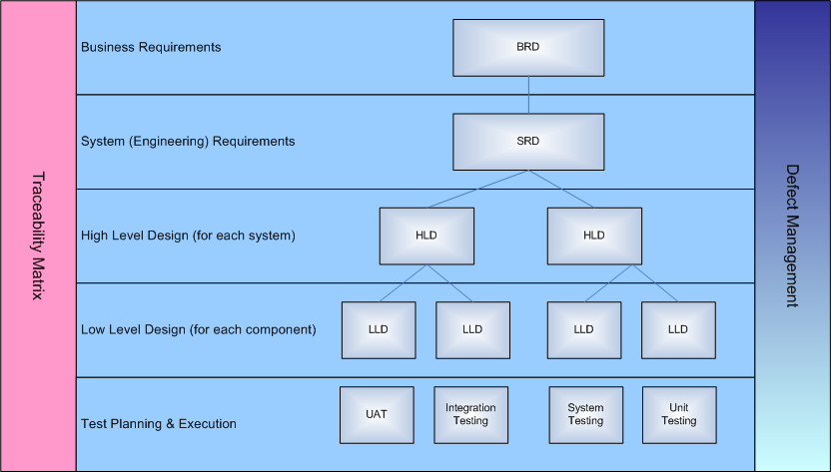

Requirements Traceability to Design Elements
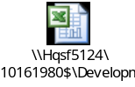

Design Overview
[This section describes how the system works today. It also describes the actors who currently uses the system, the workflow and existing use cases - how the actors are using the system].

Design Summary

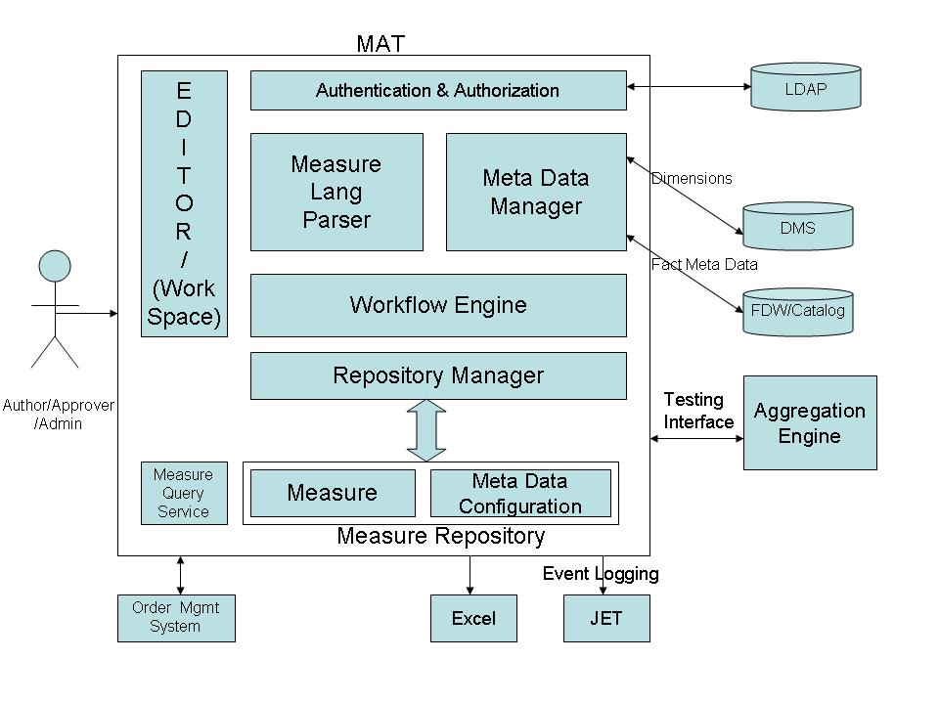

Component Summary

Embed xls

Design Assumptions
This section reminds the reader the functionality, components or business process not included in this project.

Design Risks
This section reminds the reader the functionality, components or business process not included in this project.

Architecture Implications
This section reminds the reader the functionality, components or business process not included in this project.

Error Handling

Embed xls

Test Plans
[This section describes how the system works today. It also describes the actors who currently uses the system, the workflow and existing use cases - how the actors are using the system].

System Test Cases

ints

Integration Test Cases

Embed xls

